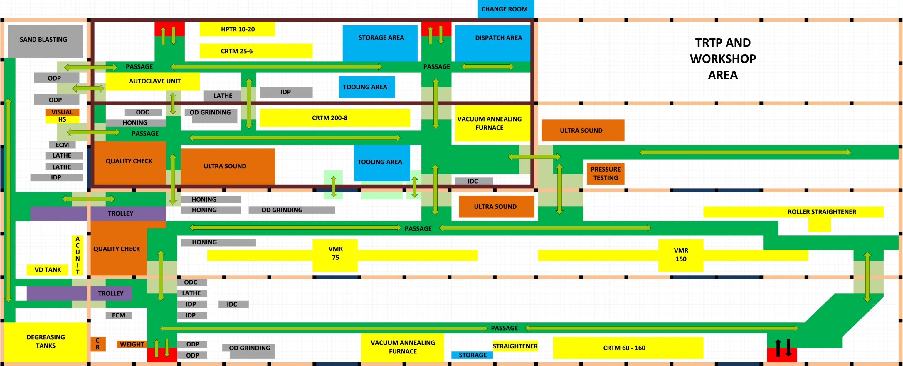**STP AHWR PLANT LAYOUT**

|  |  |  |  |
| --- | --- | --- | --- |
|  | Machine working processes – no material is removed. |  | Crane pillar line. |
|  | Testing of tube. |  | Exit or entry. |
|  | Tube and worker path – intrabay. |  | Empty area or other plant. |
|  | Tube and worker path – inter bay. |  | Crane pillar truss or ladder. |
|  | AHWR crane pillar line. |  | Passage way for tube or workers. |
|  | Trolley carriage. |  |  |
|  | Metal removal processes. |  |  |
|  | Storage and dispatch. |  |  |
|  | Crane pillar point. |  |  |
|  | Worker path inter – bay. |  |  |

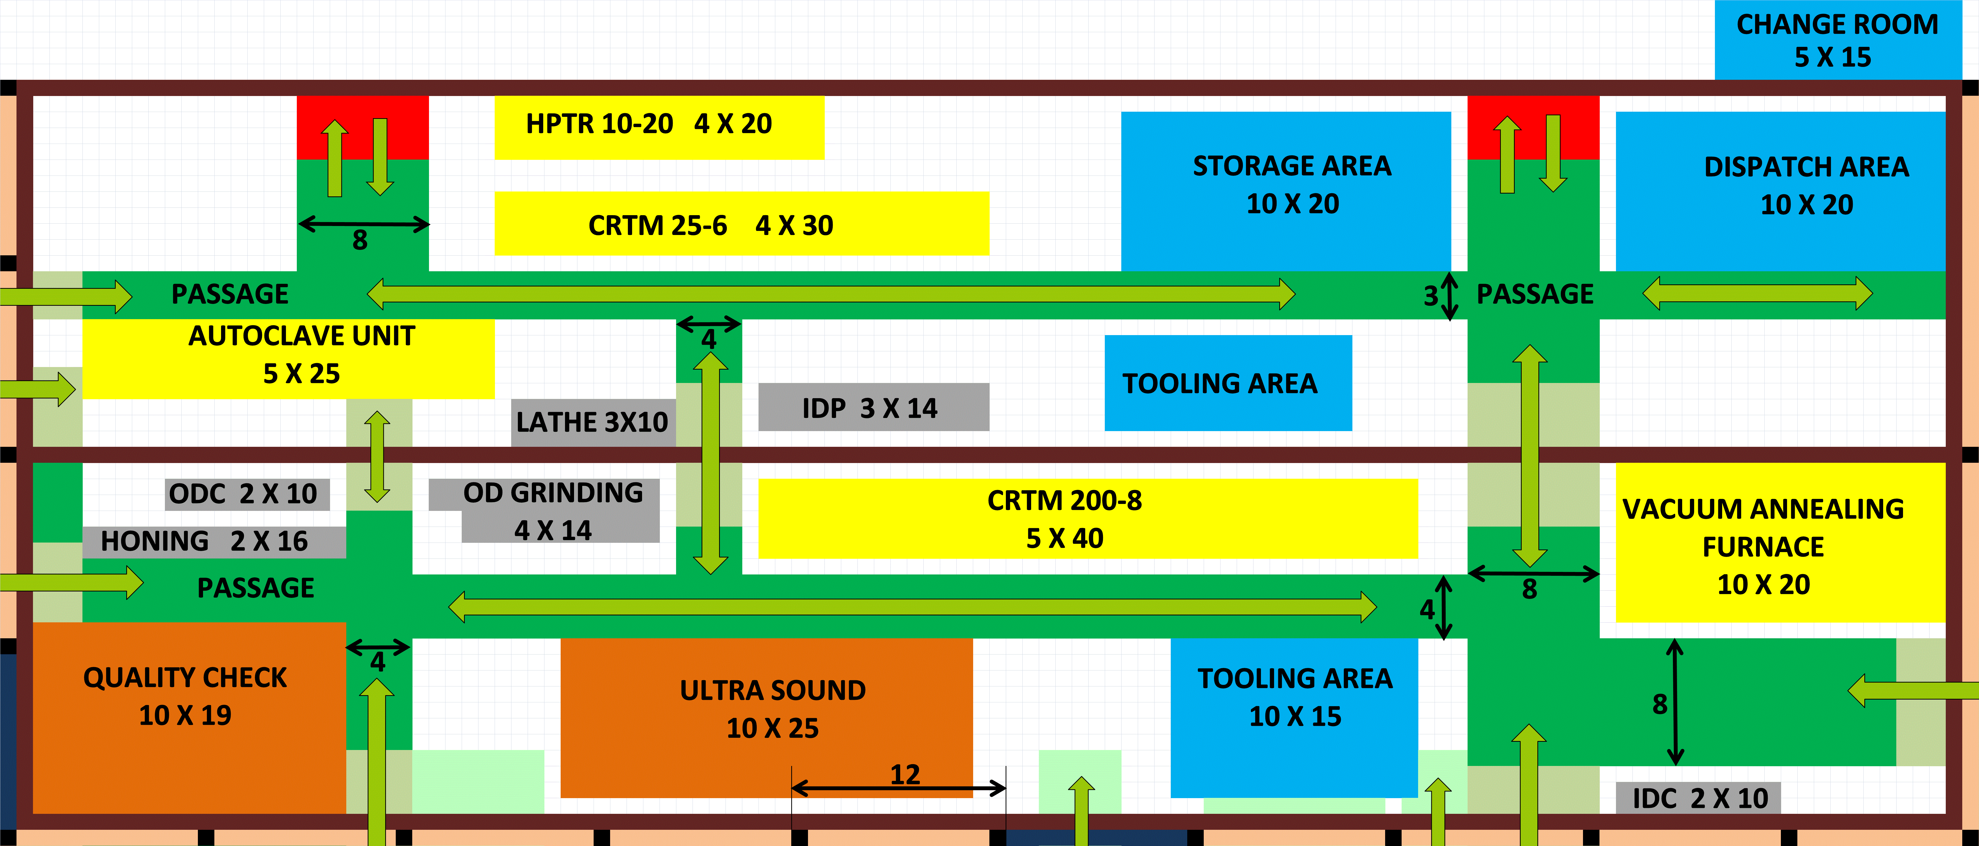“All dimensions are in meters”